***System 4***

***System to push boxes on a conveyor***

1. **Kinematics model:**

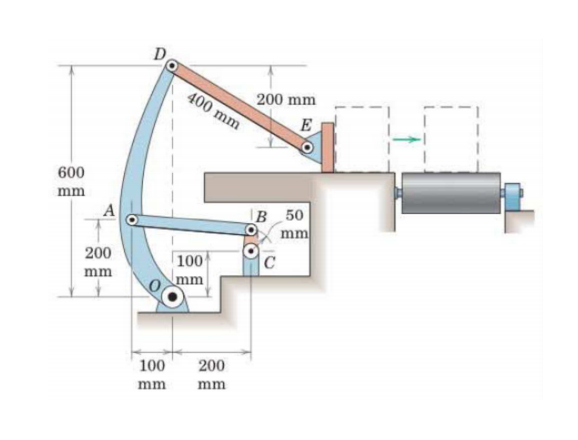 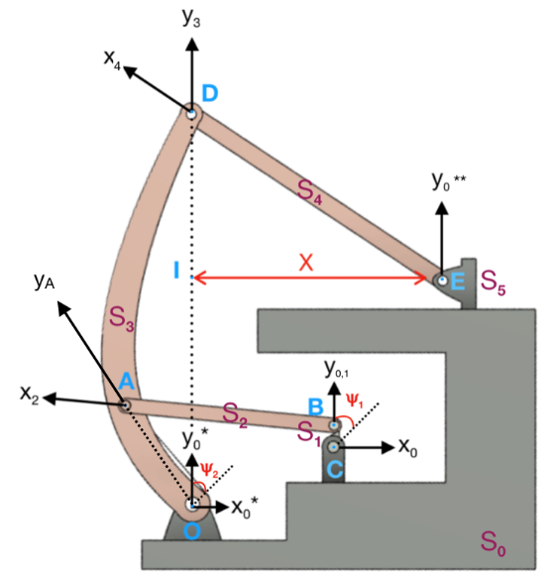

The system is composed by 6 solids: Grounded base (Solid 0), Beam BC (Solid 1), Beam AB (Solid 2), Beam OAD (Solid 3), Beam DE (Solid 4), Box pushing member (Solid 5).

The purpose of this system is to push boxes onto a conveyor belt. This is achieved by the introduction of rotation at point C in order to continuously rotate beam BC around point C. As beam AB is connected to both beam BC and OAD, the rotation introduced at point C will cause lever OAB to rotate a certain amount in a cyclical manner. Finally, this puts the beam DE into anticlockwise rotation, thus translating the box pushing member in the positive horizontal direction.

The mentioned solids are linked by the parameters Ψ1, Ψ2 and X in the following manner:

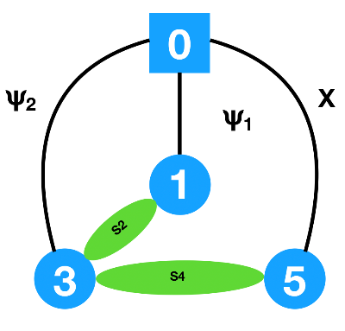

Where **Ψ1** is the input angle associated with the rotation of Solid 1 through the change of reference frame **R0 to R1**, and  **Ψ2** is the output angle associated with the rotation of Solid 3 through the change of reference frame from **R0* to R3**. The axis **y0** is collinear with **y0\***. To help define the input-output angle relation the angle **𝛼** is introduced, that is the angle between R3 and RA. **X** is the displacement associated with the varying distance **IE**.

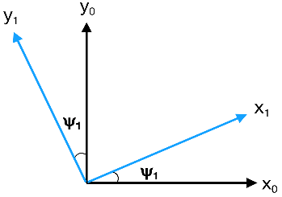         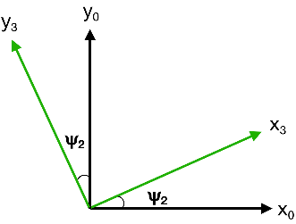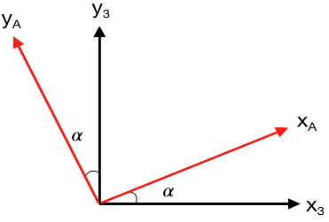

In the following pages, we utilized the Matlab software to graph the equations obtained by the given geometries.

1. **Displacement:**

After defining our parameters and constraints, we began our mathematical interpretation by obtaining the displacement of the block E (X) in terms of the output angle at point O (Ψ2).

To do this we utilized the constraint equation that the beam which connects Solid 3 to Solid 5 (vector DE or Solid 4) imposes, after manipulating the vector given we finally end up with the following equation:

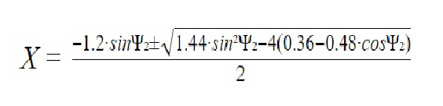

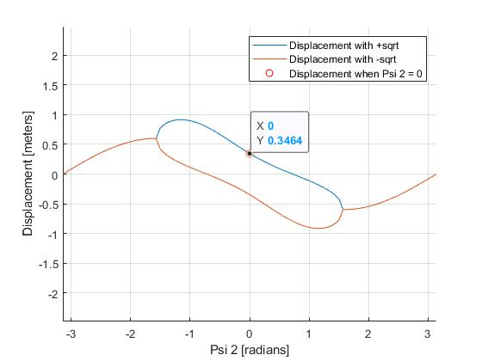After plotting both versions of the displacement on Matlab, the values of the version where the square root is subtracted do not include one of our initial conditions. Which is that when Ψ₂=0, the displacement, is 0.3464 meters (the base of the right angle triangle formed by the points D, I and E).

However the version of the equation that adds the square root does include the value previously explained, thus indicating that this is the correct one to use. This graph represents the displacement of Solid 5 when Solid 3 (beam OAB) is allowed to freely rotate 360º, which is physically impossible. Only the portion of the equation for which Ψ₂ exists with respect to Ψ₁ will give us an accurate range of displacement for Solid 5.

Therefore the Input-Output angle relation had to be obtained.

1. **Input-Output angle relation**

We have established the relation between the displacement and the output angle, however, we are missing the relation between the input and output angle. As a matter of fact, finding a workable relationship between the input-output angles was the most difficult part of this project. We utilized the constraint equation given by Solid 2, which results in:

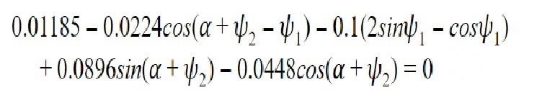

The following graph was obtained from Geogebra (a graphing calculator website) after typing in the previous equation:

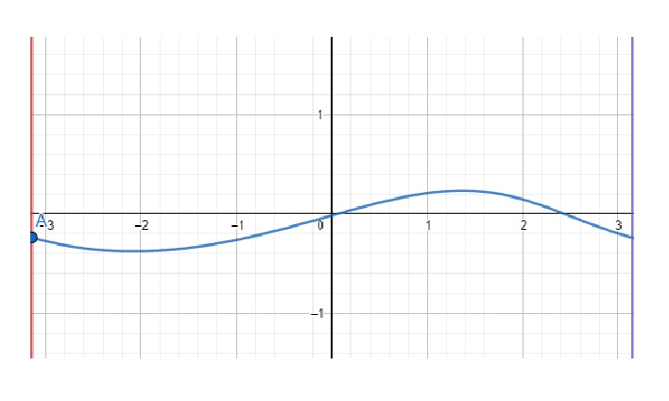

As this equation is inseparable, we had no straight forward way of simplifying **Ψ2** in terms of **Ψ1**, thus we applied Euler’s forward method to get an approximated version to use in our displacement.

Euler’s forward method: yₙ₊₁=yₙ+h f(xₙ,yₙ)

To use this method, we first defined the following:

* The discretization step (h): we defined it in our Matlab script to be 0.1, this is an arbitrary amount with no real criteria used.
* The initial conditions (xₒ,yₒ): as the only piece of information we have on this inseparable equation is our graph from Geogebra, we made a vertical line (x=- $π$) and estimated graphically by plotting a point where this vertical line intersects. Which is point A: (xₒ,yₒ)=(- $π,$-0.23914).
* The function f(xₙ,yₙ): is the implicit derivative of the inseparable equation.

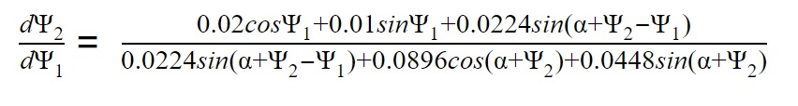

We programmed the Euler’s forward method in Matlab by using a for loop and the previously described components. After running our script, we obtain the following graph:

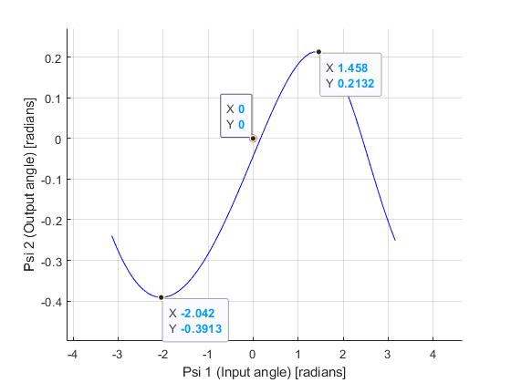

The main difference between this graph and the previous graph is that the axes in this one are equal but on the other one they are not. Other than that, the values are very similar and we assume it to be a correct approximation to the inseparable equation.

Which gives us the following information:

Ψ₂= [-0.3913 rad,+0.2132 rad] with respect to Ψ₁=[-𝜋,𝜋].

We plugged this values into the displacement equation to obtain a correct approximation to the distance for which Solid 5 travels and graphed it.

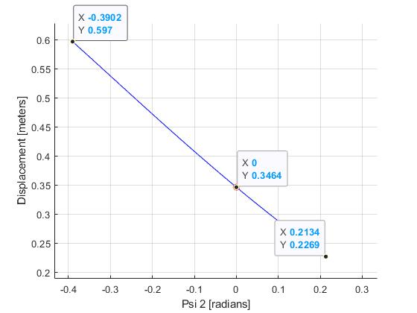From this, we can interpret an accurate displacement of Solid 5. When beam OAD (Solid 3) rotates in an anti-clockwise manner (when the angle is positive) the Box pushing member (Solid 5) moves in the negative horizontal direction causing the whole system to retract reaching a distance of 0.2 meters from point I; but when it rotates in a clockwise manner (when the angle is negative) the Box pushing member (Solid 5) moves in the positive horizontal direction pushing the box onto the conveyor belt and reaching a distance of 0.6 meters from point I.

1. **Velocity**

As we already know that the velocity is the derivative with respect to time of the displacement, which means that all we had to do was derive the displacement to get the equation of velocity. Resulting into the following equation:



To accurately obtain the magnitudes of the velocity for which Solid 5 travels, we had to also have some information on how the angular velocities are related to each other. In order to do this we derived with respect to time this initial equation of the input-output angle relationship, so we could have an equation that links the 2 angular velocities together. Which gives:

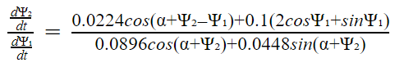

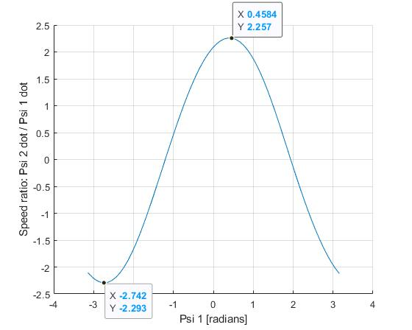

To simplify we assumed that the angular velocity given by the motor or input at point C ($\frac{dψ_{1}}{dt}$) to be $1 \frac{rad}{s}$.

In other words this graph represents not only the speed ratio in relation to the input angle, but the output angular velocity in relation to the input angle.

Thus we could plug this function into velocity equation, giving us the following graph:

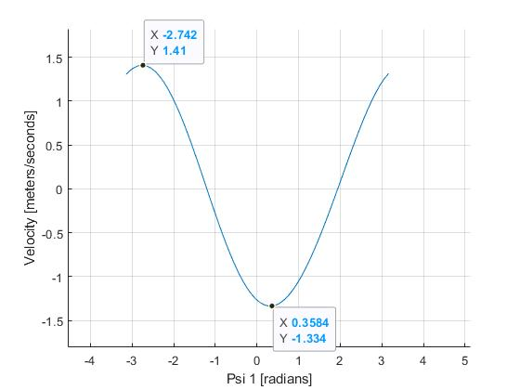

1. **Conclusion**

The rotation from the input angle (𝛹₁=[-180º, 180º]) creates a range from which Solid 3 will constantly rotate back and forth from (𝛹₂=[-22.42º, 12.21º]). With this, Solid 5 will only be able to displace from +0.2m**⋅x₀** when𝛹₂=-22.42º to +0.6m**⋅x₀** when 𝛹₂=12.21º from point I.

If we assume that the input angular velocity given by some motor connected to point C to be $1 \frac{rad}{s}$ then when 𝛹₁=-2.742 rad the $\frac{dψ_{2}}{dt}=-2.293 \frac{rad}{s}$ and when 𝛹₁=+0.4584 rad the $\frac{dψ_{2}}{dt}=2.257 \frac{rad}{s}$. Thus indicating that the angular velocity can increase or decrease with relation to 𝛹₁.

The maximum velocity of when Solid 5 is being pushed (translated in the positive horizontal direction of **x₀**) is +1.334 ms⁻¹**⋅x₀** when the input angle is 𝛹₁=0.3584 rad; When it is being pulled (translated in the negative horizontal direction of **x₀**) the maximum velocity is -1.41 ms⁻¹**⋅x₀** when the input angle is 𝛹₁=-2.742 rad.

The people who designed this system wanted to create a system that could consistently push boxes, to do this they created Solid 3, 4 and 5. However the main problem to be solved was the creation of Solid 1 and 2 as Solid 3 should not rotate all 360º, thus this two solids not only allow for Solid 1 to be continuously rotated all 360º but this rotation only partially rotates Solid 3 in a certain range. This is a practical solution to a simple problem.

In conclusion, this study of the system helped us understand the magnitudes of the parameters we had defined in the beginning and have a physical and mathematical understanding of the system. We also learned the versatility and utility of Matlab as this helped us to simplify the process for the Euler’s forward method approximation of the inseparable equation and obtain all the graphs shown in the report.

***Post-Scriptum:***

* Appendix I includes all our work for obtaining all the equations used.
* Appendix II includes the code from which we did the Euler Forward Method and obtained all the graphs from.